**13. Spring MVC - Request Params and Request Mappings**

**Spring MVC - Request Params**:

Here we are learning how to read HTML form data by using @RequestParam Annotation

**Code Example**:

1. We want to create a new method to process form data
2. Read the form data: student’s name
3. Convert the name to upper case
4. Add the uppercase version to the model

**Instead of using HttpServletRequest**:

@RequestMapping("/processFormVersionTwo")

**public** String letsShoutDaude(HttpServletRequest request, Model model) {

// read the request parameter from the HTML form

String theName = request.getParameter("studentName");

.....

}

**Bind variable using @RequestParam Annotation**:

The **@RequestParam** will read form data and automatically bind it to a parameter coming into our method.

@RequestMapping("/processFormVersionTwo")

**public** String letsShoutDaude(

@RequestParam("studentName") String theName, Model model) {

// now we can us the variable: theName

}

**Behind the scenes**:

1. Spring will read param form request: studentName
2. Bind it to the variable: theName

**Spring MVC - Request Mappings (Add Controller @RequestMapping)**:

Here we add controller @RequestMapping. This is a very nice way to group our request mappings together and also a great technique for resolving any problems or conflicts that may have with other request mappings.

**Adding Request Mappings to Controller**:

1. Serves as parent mapping for controller
2. All request mappings on methods in the controller are relative
3. Similar to folder directory structures

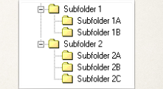

**Controller Request Mapping**:

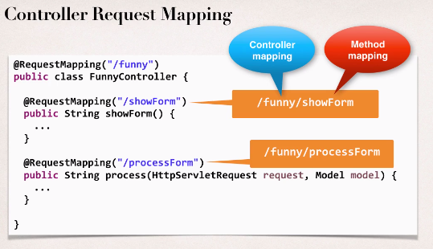

**Ambiguous mapping Problem**:

Now create a new controller and add a method and map this.

@Controller

**public** **class** SillyController {

@RequestMapping("/showForm")

**public** String displayTheForm() {

**return** "silly";

}

}

Now if we run this project, we will get error saying



This problem is occurring because the same mapping is present in HelloWorldController

**HelloWorldController.java**:

@Controller

**public** **class** HelloWorldController {

// need a controller method to show the initial HTML form

@RequestMapping("/showForm")

**public** String showForm() {

**return** "helloworld-form";

}

// add a controller method to read form data and add data to the model

@RequestMapping("/processFormVersionThree")

**public** String letsShoutDaude(@RequestParam("studentName") String theName, Model model) {

// convert the data to all caps

theName = theName.toUpperCase();

// create the message

String result = "Hello Programmer " + theName;

// add the message to the model

model.addAttribute("message", result);

**return** "helloworld";

}

}

**Resolving Ambiguous Mapping**:

For solve this problem move back to **HelloWorldController** controller and add parent mapping

@Controller

@RequestMapping("hello")

**public** **class** HelloWorldController {

// need a controller method to show the initial HTML form

@RequestMapping("/showForm")

**public** String showForm() {

**return** "helloworld-form";

}

// add a controller method to read form data and add data to the model

@RequestMapping("/processFormVersionThree")

**public** String letsShoutDaude(@RequestParam("studentName") String theName, Model model) {

// convert the data to all caps

theName = theName.toUpperCase();

// create the message

String result = "Hello Programmer " + theName;

// add the message to the model

model.addAttribute("message", result);

**return** "helloworld";

}

}

We also have to change the JSP page **main-menu.jsp (**href=*"hello/showForm"***)**

<!DOCTYPE html>

<html>

<head>

<title>Spring MVC</title>

</head>

<body>

<h2>Spring MVC Demo Home Page</h2>

<hr>

<a href=*"hello/showForm"*>Hello World Form</a>

</body>

</html>

**Example**:

13-springmvc-requestmapping

13. Spring MVC - Request Params and Request Mappings